 | Mosses and Climate Change  Change and Adapt Activity | 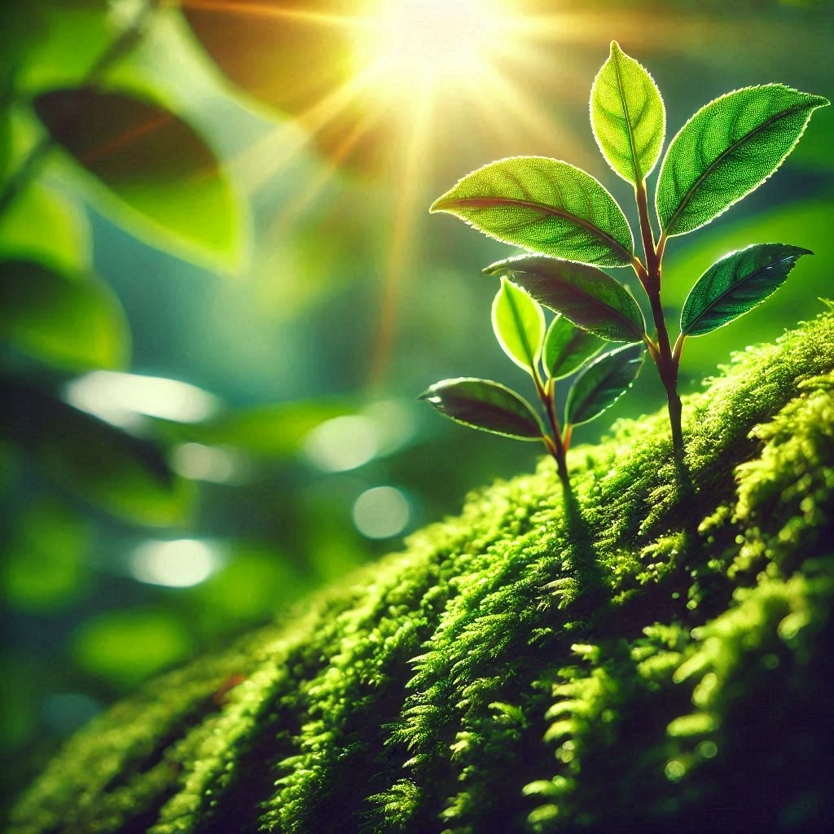

What do you know about mosses?
- What are mosses and where do they grow?
- Why are they important?
- How will mosses adapt to climate change?

Activity 1. Do this

- Look around your school grounds for mosses.
- Observe each moss carefully using a hand lens, take photos and notes.
- How many different types of moss do you find in your school grounds?

Activity 2. Read this information
Mosses are tiny plants that have small leaves and short stems. They are good at colonising bare rock and starting an ecosystem. They can grow in forests, gardens, and even on walls and roofs in cities. Mosses can hold a lot of water for their size, they can absorb pollutants from the air and water and provide homes for small organisms.
Climate change is causing the Earth's climate to change and get warmer, and this affects mosses in several ways. In Britian, some moss species that like cool and damp places might become extinct as temperatures rise. This means that the number of moss species, or biodiversity, will decrease in some areas. Additionally, as the climate changes, mosses might start to grow in new places where they couldn't survive before, changing the distribution of mosses across Britain.
Mosses do photosynthesis, taking carbon dioxide from the air and storing it in their bodies. In wetlands, when mosses die, more mosses grow on top of them. This forms layers of moss with carbon stored in it. This material is called peat.

Moss Safari Mosses and Climate Change: Change and Adapt Activity
Read these facts
Globally wetlands cover 3% of the planet, but store 30% of global carbon usually as peat, decaying moss plants.
Source: Discover wetlands
State of Nature Report 2023
Since 1970, bryophyte diversity has reduced by 59%.
Since 1970, bryophyte distribution has only increased by 26%.
One in five bryophytes are classified as threatened species in Great Britain.

A scientific model in 2020 predicted that only 30% of moss species will have adapted to the new conditions by 2050.

Use the information and facts to answer these questions
1. What is a common place you can find moss growing?
2. Why are mosses important for the environment?
3. How may climate change affect the distribution of mosses in the UK?
4. What might happen to moss species that prefer cool and damp places as the climate gets warmer?
5. Explain how changes in moss species and their habitats due to climate change could affect other plants and animals.
Glossary
Bryophyte: A type of non-vascular plant, including mosses, liverworts, and hornworts. They lack true roots, stems, and leaves, thrive in moist environments, and reproduce via spores.
Colonising: taking over a space. In ecology it refers to taking over bare land.
Biodiversity: The number of different species of plants or animals in a particular place.
Climate change: Long-term changes in temperature and weather patterns on Earth.
Distribution: Where plants or animals are found in different areas.
Threatened species: A species that is threatened with extinction from an area or globally.
Organism: any living thing that can carry out life processes independently. Organisms ranging from bacteria to complex multicellular beings like fungi plants, and animals.

Mosses and Climate Change

Change and Adapt Activity

Teacher notes
Activity 1
Looking at where different types of moss grow, will tell you their distribution. Counting the number of different types of moss (species) will tell you their biodiversity. The more species, the higher the biodiversity. Mosses can be difficult to identify, but children can group them into ones that look the same or similar.
Activity 2. Answers and discussion points for questions
1. Moss can commonly be found growing in forests, gardens, and even on walls and roofs in cities. Highlight the adaptability of mosses and their ability to thrive in various urban and natural environments.
2. Mosses help keep the environment healthy by holding water, storing carbon and providing homes for small organisms. Emphasise the role of mosses in water retention that can prevent flooding, their ability to store carbon helps to slow climate change but burning peat increases climate change, and their importance in creating habitats for other organisms.
3. Climate change can cause mosses to start growing in new places where they couldn't survive before, changing where they are found in the UK. Explain the concept of distribution and how changing climates can shift the habitats of moss species. More robust species will get a wider distribution, more specialised species will have reduced distribution or even become extinct.
4. Moss species that prefer cool and damp places might struggle to survive as temperatures rise, leading to a decrease in their numbers. Discuss the challenges mosses face with rising temperatures e.g. drying out for longer periods, being too warm allows fungi to infect moss, other plants may grow better in place of mosses. As species become extinct, their biodiversity.
5. Changes in moss species and their habitats can affect other plants and animals that rely on mosses for their habitat, potentially leading to a disruption in the ecosystem. Illustrate the interconnectedness of ecosystems and how shifts in one species can impact others, reinforcing the importance of mosses in maintaining ecological balance.

Share your pupils’ work, photos and discoveries with Moss Safari and send the best work to be put in our Moss Safari Gallery. www.mosssafari.com

