 | Tardigrades in the City  Change and Adapt | 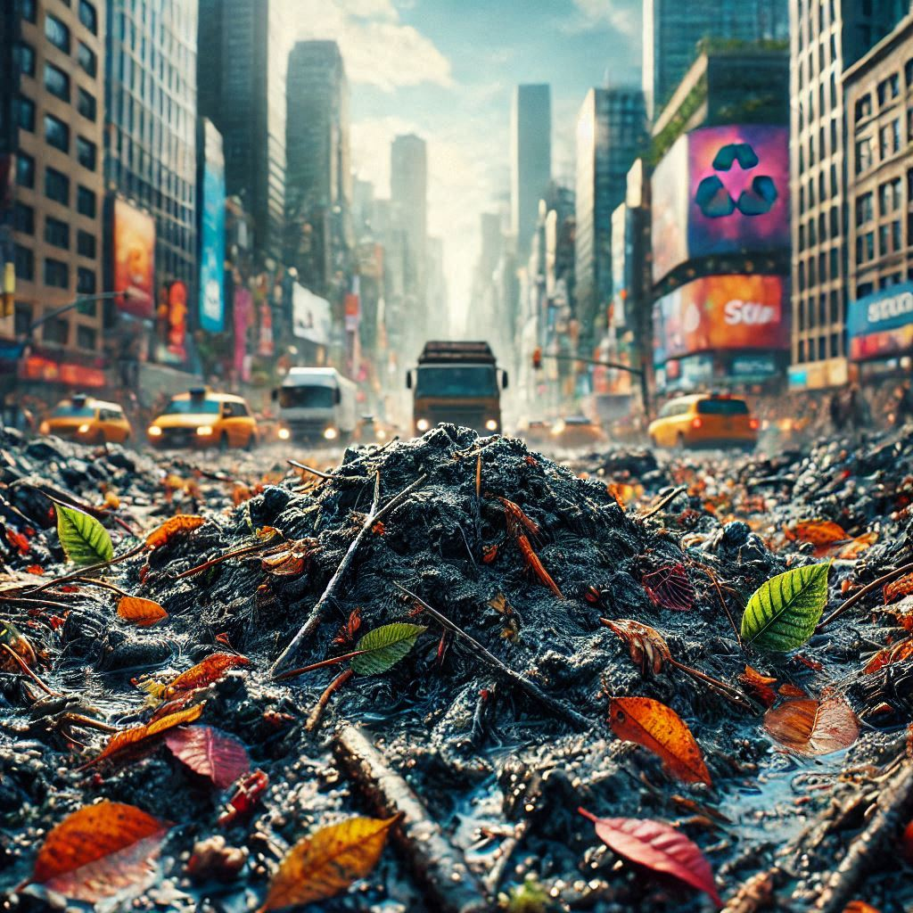

What do you know about tardigrades and their adaptations?
- What is a tardigrade? Where do they live?
- What impact do cities have on the populations of tardigrades?
- What can we do to reduce pollution in cities?

Activity 1. Read this
What are tardigrades?
Tardigrades are microscopic animals that normally live in moss and lichen. They are sometimes called ‘water bears’ as they look like little bears with long claws. There are lots of different species of tardigrades. Some species can turn themselves into a tun and survive extreme conditions such as freezing, drying out, radiation and even being in space.

A tardigrade x40  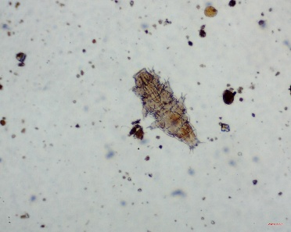 | Why are cities polluted?  Cities have high numbers of people living in one place and this causes more waste and more traffic. Air pollutants include carbon monoxide and nitrogen oxides. Water pollutants include herbicides and pesticides. The ground gets polluted with heavy metals and microplastics.
Can tardigrades survive in cities?  Scientists in Argentina studied the populations of tardigrades living in a city called Salta. They compared the species living in three different areas of traffic. High traffic, medium traffic and low traffic. They found tardigrades in mosses in all three areas, but there were some differences. |  | Table 1. Comparing tardigrades in different areas
  Traffic | Biodiversity | Abundance
  Low | High | Medium
  Medium | Medium | Medium
  High | Low | High

Tardigrades in the City

Change and Adapt

Activity 2. Use Activity 1 to answer these questions
- Where do tardigrades (water bears) usually live?
- Why are cities often polluted?
- What are the main sources of pollutants?
- What did the scientists in Salta, Argentina compare?
- What did the scientists find out?

Activity 3: Look at Table 1
Glossary  Abundance: In ecology, this refers to the number of individuals of a particular species in a specific area.  Biodiversity: In this case, the number of different species of tardigrades living in one place. A few different species means a low biodiversity, many species mean high biodiversity. | Compare low traffic areas with high traffic areas.  Using the glossary, describe the difference in tardigrade abundance and biodiversity in these two areas.

Activity 4. Hope
In 2020, Argentina was locked down due to the COVID-19 pandemic. This meant that the high traffic areas became low traffic areas.  In all traffic areas, the abundance and biodiversity of tardigrades increased. | - What impact did lockdown have on traffic?  - Which pollutants were likely to have been reduced?  - What could we do to reduce city pollution more permanently?

Tardigrades in the City

Change and Adapt

Teacher Notes and answers
Do a Moss Safari using moss or lichen from your local area and look for tardigrades. They are easy to find, and you will see them crawling around the slide. Use the video on Moss Safari’s website if you cannot find your own.
Activity 1 Read through this with your class or get them to do it independently.
Activity 2
- Tardigrades are microscopic animals that normally live in moss and lichen.
- Cities have high numbers of people living in one place, which causes more waste and more traffic.
- Air pollutants include carbon monoxide and nitrogen oxides.
Water pollutants include herbicides and pesticides.
The ground gets polluted with heavy metals and microplastics.
- They compared the species of tardigrades living in three different areas with different levels of traffic: high traffic, medium traffic, and low traffic.
- Tardigrades were found in mosses in all three areas, but there were differences.
Activity 3
Low traffic areas support a greater variety of tardigrade species (high biodiversity), while high traffic areas have fewer species (low biodiversity).In contrast, high traffic areas have a larger overall number of tardigrades (high abundance), whereas low traffic areas have a moderate number (medium abundance). This suggests that while tardigrades can survive in polluted, high-traffic environments, only a few species thrive there, reducing overall biodiversity.
Activity 4
1. During the 2020 COVID-19 lockdown in Argentina, high traffic areas became low traffic areas.
2. The reduction in traffic likely led to a decrease in air pollutants such as carbon monoxide and nitrogen oxides. There may also have been a reduction in water pollutants like herbicides and pesticides, as well as ground pollution from heavy metals and microplastics.
3. Reducing traffic by promoting public transport, cycling, and walking. Implementing stricter regulations on emissions from vehicles and industries. Encouraging the use of environmentally friendly alternatives to pesticides and herbicides. Reducing waste and microplastic pollution through better waste management and sustainable product choices.
References. Gonzalez-Reyes et al (2000) and González-Reyes et al (2024).
Share your pupils’ work, photos and discoveries with Moss Safari and send the best work to be put in our Moss Safari Gallery. www.mosssafari.com

